**Introducing the Orthodox Church**

Christians in western Europe belong to different denominations such as Roman Catholic, Anglican, Methodist etc, but in eastern Europe & the Middle East the majority of Christians belong to one church: the Orthodox Church which maintains an unbroken tradition going back to Apostolic times.

At the time of the Apostles the known world shared a common culture, the Roman Empire.

Latin & Greek were the languages spoken. But in time the unity of the Roman Empire was broken due to many western parts of the empire falling to barbarian invasions and eastern parts falling under Muslim control. International commerce declined, people no longer travelled or mixed as freely as before. The Christian world began to split into two blocks, the Greek speaking east & the Latin speaking west.

Other differences included the break-up of the western empire and power concentrated in the hands of the Pope. He had to take control in the vacuum. Matters came to a head when the Pope tried to force the Church in the east to accept an addition to the Creed, the so-called “filioque clause” which asserts that the Holy Spirit proceeds from the Father and the Son. The eastern bishops thought this was wrong as it devalued the unity and equality of the Trinity and also this had not been up for discussion but the Pope was claiming to have the power to impose his will over his brother bishops.

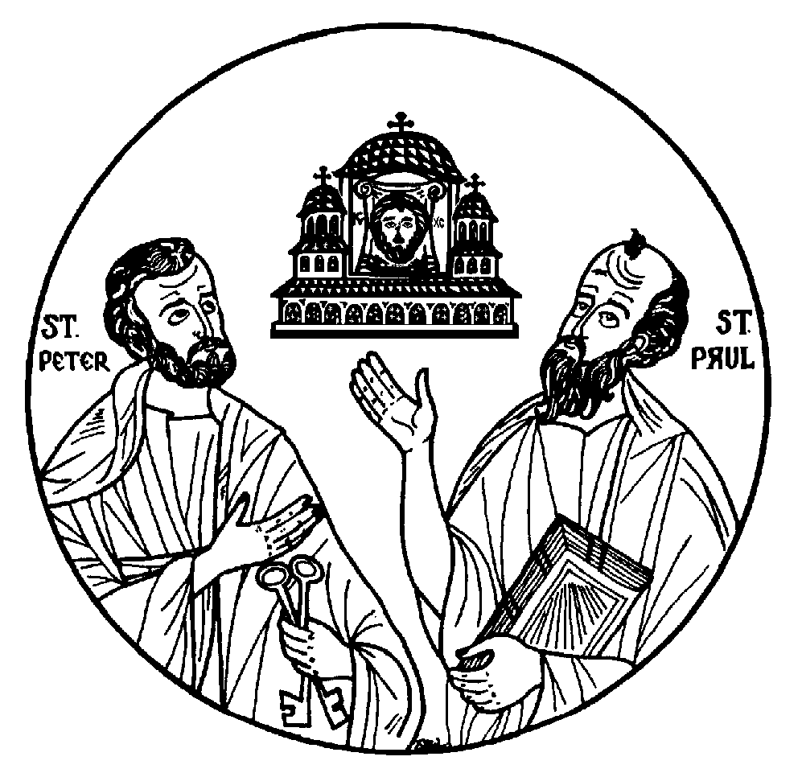

This was the straw that broke the camel’s back. The dispute led to the Great Schism (Split) of 1054. The two sides officially ceased to acknowledge each other but the relationship was irreparably soured when crusaders sacked and ran riot in 1204 in the holy city of Constantinople as if it was an enemy capital.

The four horses on St. Mark’s Basilica in Venice were just some of the artwork stolen by the crusaders.

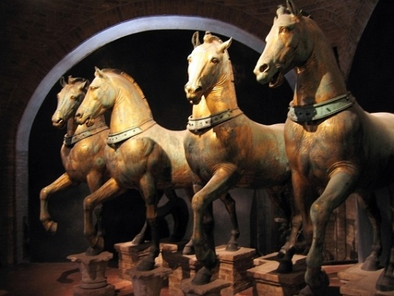

Orthodoxy was not directly affected by the Protestant Reformation, but since the Reformers rejected many of the hallowed customs of the Church, they were distancing themselves not just from Rome but from the church of the east.

Orthodox worship is colourful, everything is sung or chanted. The clergy’s vestments, the incense, the votive candles lit by the worshippers and the icons which are venerated.

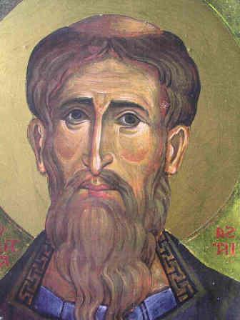

Why does it need to be so elaborate? Worship involves the mind, heart, senses and soul. Orthodox worship is meant to give us a foretaste of heaven. Central to Orthodox thinking is the belief that the world exists to be transfigured, that is filled with divine radiance. The Orthodox Liturgy through its stately rituals, poetic language and solemn melodies offers us a glimpse of life as it is meant to be lived.

C:\Documents and Settings\Adrienne\Local Settings\Temporary Internet Files\Content.IE5\B84SDJUV\MC900058392[1].wmf

**Praying for the Departed**We believe that the living and departed are united in divine communion. Since Christ is risen from the dead, all those who die in Christ are risen along with him. Praying for the departed witnesses to our faith in the Resurrection.

**Mary the Mother of God**We call Mary the “Theotokos” or God-bearer. This reminds us that Jesus was no mere man but the Second Person of the Trinity who for our sake became man.

C:\Documents and Settings\Adrienne\Local Settings\Temporary Internet Files\Content.IE5\7HP9SLRG\MC900434339[1].wmf

Mary gave birth to God, and we also stress the significance of Mary’s response to God, who required our cooperation. Mary said yes to God, offered herself unconditionally and thus made the Incarnation possible.

**The Saints** are in communion with the living, they are able to assist us with their prayers. We believe that sites once closely associated with the saints always retain a certain sanctity and spiritual power. Pilgrimages are a common feature of Orthodox life.

**Icons** are appreciated by Christians of many denominations. We venerate the actual person or event represented by the icon, much like a mother kisses the photograph of an absent son. It doesn’t matter if an icon is hundreds of years old or printed off the internet on A4 each is venerated equally. Just as at home we have photos of loved ones so we have God’s loved ones in God’s home, a church building.

**The Bible**Orthodox belief and worship are rooted in the Bible and our prayers rely heavily on biblical allusions. Scripture has to be viewed within the context of the Church. The New Testament was also the work of the Church. The Apostolic teaching preceded the recording, writing and compilation of the New Testament and it was the Church’s task to decide which texts were authentic and inspired. It is when the bible is divorced from the Church that it becomes a playground for academics and slowly dissolves under their gaze or it becomes a fossil and cannot be interpreted.

**Today** more and more people are attracted to the stability of the Orthodox faith. *“We do not change the everlasting boundaries which our fathers have set but we keep the Tradition just as we received it”* wrote St. John of Damascus.

Orthodoxy is a fairly demanding faith when it is lived properly including regular private prayer, periods of fasting, self-examination, confession etc. Yet Orthodox parish life is a relaxed environment in which one can give and receive and yet be oneself.

To those who are interested in Orthodoxy I can only say as Philip said to Nathaniel, “Come and see! (John 1:46)

*Taken from Orthodox Leaflet Number 1 by Deacon Ian Thomson. Bluestone Books.*



For more information on the Orthodox Church and your local communities consult these web sites:-

<http://www.thyateira.org.uk/>

<http://www.antiochian-orthodox.co.uk/>

<http://www.exarchate.org.uk/>

<http://www.sourozh.org/>

<http://www.rocor.org.uk/>